[insert SDBP logo here]
[Date]
Dear [Recipient’s name],
My name is [Your name] and for the last [XXX years I have served as the Family Engagement Coordinator for XXX Deaf-Blind Project]. The mission of our project is to support children birth–21 years of age with combined vision and hearing loss and their families. [Name] provided your contact information to our project so we could offer our support to you and your child.
Here’s what we, [XXX Deaf-Blind Project], can offer you:
[Add details here—bulleted list of specific opportunities your project provides, such as trainings, family groups, social media, website, and 1:1 support from project staff in the home]
We look forward to getting to know your family and supporting you as your child grows. We will be contacting you in the weeks ahead to see how we can best support you, but in the meantime, please do not hesitate to contact us with any questions.
We understand that caring for an infant with combined vision and hearing loss can be a challenging experience. It is our hope that the information on the next two pages will provide you with some helpful tips and resources.
Sincerely,
[FEC (or assigned staff) signature]
[FEC (or assigned staff) name]
[Email]
[Phone number]
[SDBP website address]

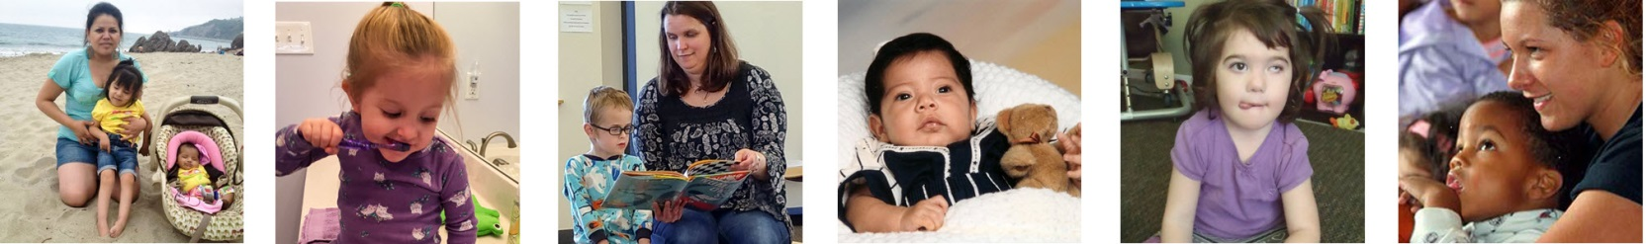

Consider This...

Touch
Your baby will come to know you by your touch. Touch is the beginning of communication and the starting point for shaping your child's learning and development. Touch helps your child know that you are there and that you are paying attention. It is essential to bonding.
Here are some tips:
- Before you interact with your child, let them know you are there by using a consistent touch cue (like a gentle tap on their shoulder or arm or a kiss on the cheek).
- Make sure your infant or toddler has frequent opportunities to touch and play with objects and people around them.
- Place or hang objects (such as toys or household items) near them so they can explore many different textures and shapes.
To learn more about using touch with children who have combined vision and hearing loss, please go to: https://www.uvm.edu/sites/default/files/Center-on-Disability-and-Community-Inclusion/ResearchSummary3Deafblind.pdf

Communication
Holding and touching your infant is the foundation for communication. There are many different ways your baby will communicate with you, including sounds, cries, movements (reaching, stiffening, relaxing), and facial expressions. Over time, you will learn what their signals are communicating.
Here are some tips:
- Acknowledge any attempt your child makes to interact with you.
- Provide opportunities for turn taking.
- Use communication for a variety of purposes—play, explain what is happening around your child and to them, sing and read to them.
Ideas for more ways to build communication can be found here: http://documents.nationaldb.org/products/early.pdf

Early Intervention
Early intervention services during infancy and early childhood provide critical opportunities to influence the development of children with combined vision and hearing loss. What are some examples of early intervention services? Here is a helpful overview: http://www.parentcenterhub.org/ei-overview

Other Resources
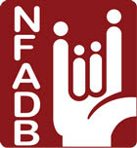
The National Family Association for Deaf-Blind (nfadb.org) is a nonprofit organization that brings families together and offers support. We encourage you to become a member so that you can connect with other families who have similar situations and experiences. To read some family stories, go to: nfadb.org/stories
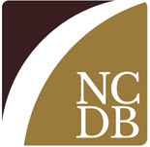
The National Center on Deaf-Blindness (nationaldb.org) has a large collection of information on combined vision and hearing loss and can link you to upcoming trainings and support. They also have a section on their website specifically for families: nationaldb.org/families
WonderBaby (wonderbaby.org) is a support site by and for parents of young children with visual impairments or multiple disabilities. It includes articles and posts on a wide range of topics with a wealth of tips and activities.
[Add state-specific or condition-specific organizations (e.g., family groups, Part C program, CHARGE Syndrome Foundation, etc.)]

