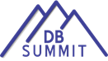

July 20, 2014 OSEP/NCDB DEAF-BLIND SUMMIT

AGENDA

8:00 AM – 8:30 AM Foyer: Wilson Suite ABC
- Registration

8:30 AM – 9:45 AM Wilson Suite ABC
- Opening [D. Jay Gense, NCDB Project Director; Jo Ann McCann, OSEP Project Officer/Deaf-Blind Portfolio Lead]
  - Welcomes and acknowledgements
  - Introductions of new project personnel
  - ‘Setting the table’ for the day/process
9:45 AM – 10:15 AM
- Break (Meet and Greet)

10:15 AM – 11:30 AM Rooms listed in bold below
Concurrent Session A

Wilson Suite ABC  Early Identification  & Referral  Barb Purvis  Tanni Anthony | Harding (Mezzanine)  Building Network  Neurons  Gail Leslie  Katie Humes | Coolidge (Mezzanine)  Transition  Mike Fagbemi  Susie Morgan  Toni Hollingsworth | Hoover (Mezzanine)  Professional  Development  Cyral Miller  Teresa Coonts
11:30 AM – 1:00 PM
- Lunch on your own

1:00 PM – 2:15 PM Rooms listed in bold below
Concurrent Session B

Wilson Suite ABC  Intervener Services  Peggy Malloy  Julie Durando | Harding (Mezzanine)  Intensive TA  Kathy McNulty  Jerry Petroff | Coolidge (Mezzanine)  Literacy  Nancy Steele  Annette Carey | Hoover (Mezzanine)  Initial Deaf-Blind Professional Licensure  Chris Montgomery  Linda McDowell
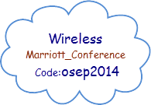
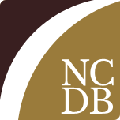
2:15 PM – 2:30 PM
- Break

2:30 PM – 3:45 PM Rooms listed in bold below
Concurrent Session C

Wilson Suite ABC  Intervener Training Modules (OHOA)  Amy Parker  Leslie Buchanan | Harding (Mezzanine)  Family Engagement  Diane Haynes  Clara Berg  Sherri Stanger | Coolidge (Mezzanine)  ‘Passing the Baton’ - retirements/transitions  Lisa Poff  Maurice Belote | Hoover (Mezzanine)  Data Management  Michelle Clyne  Tracy Evans Luiselli

3:45 PM – 4:00 PM
- Break

4:00 PM – 4:45 PM Wilson Suite ABC
- Closing [D. Jay Gense, NCDB Project Director]
  - What’s next
  - Wrap-up

5:00 PM – 6:00 PM Delaware Suite
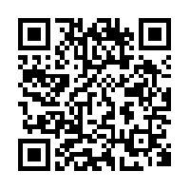
- Celebrations Social
Meeting Evaluation
Please don’t forget to tell us what you thought of the meeting! Use the link or
the QR Code to access the DB Summit evaluation.

http://www.surveygizmo.com/s3/1731389/2014-Deaf-Blind-Summit
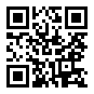
DB Connect ~ DB Summit Social App! Stay connected throughout the day.
https://nationaldb.org/dbconnect

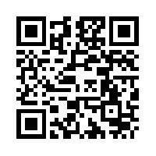
Deaf-Blind Summit 2014 Group (Meeting materials, forums, session summaries)
https://nationaldb.org/groups/page/75/db-summit-2014

We would like to extend a big thank you to the State Deaf-Blind Project personnel who participated in the DB Summit planning process: Maurice Belote (CA), Leslie Buchanan (UT), Cassondra Glausier (LA), Heather Herbster (OH), Tracy Luiselli (NEC) Jennifer Tarnay (HI/PB), Emily Taylor-Snell (FL/VI)

