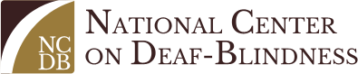
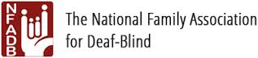
FAMILY-to-FAMILY COMMUNITIES (F2FC)
Connecting Families of Children with Deaf-Blindness

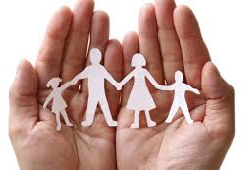
Because deaf-blindness is a low incidence disability, families of children who are deaf-blind often have difficulty meeting other families who share similar triumphs and challenges. The National Family Association for Deaf-Blind (NFADB), the National Center on Deaf-Blindness (NCDB), and State Deaf-Blind Projects are working together to offer a unique way for families to connect with one another. Parents of children with deaf-blindness know and understand the needs of families of children with deaf-blindness more than anyone; therefore, Family Engagement Coordinators and Family Leaders will facilitate this collaborative project.

FAMILY-TO-FAMILY COMMUNITIES (F2FC)
- Bring families together to talk with one another ~
- Support and encourage one another ~
- Share the journey of life raising a child who is deaf-blind ~

F2FC Pilot Project Summary~ Southeast States~ November 2014-2015
- Nine families, four facilitators, and 2 moderators formed two F2FCs.
- They came together during monthly conference calls to share triumphs and challenges, share information and resources, and to form connections with one another.
- One parent stated, “it was like this little hour of sanity where you could talk with people who kind of understood where you were…”
- Now, F2FC Partners are ready to expand this project…more states, more families, more connections!

Format of Family-to-Family Communities:
- Family-to-Family Communities, comprised of 8-10 families, will be established based upon the age of their child, the nature of their child’s disability, and participation preferences.
- Each F2FC will be guided by two Facilitators, who have participated in NFADB leadership training.
- Each F2FC will meet monthly via phone or video conference; topics will be decided by the members.
- F2FC members are encouraged to connect with each other via phone, email, or social media.

Are you interested in joining a Family-to-Family Community??? Find the registration form here:
https://gsap.wufoo.com/forms/family-2-family-communities/
Carol Darrah,
F2FC Project Coordinator
cdarrah@uga.edu
(706) 542-2433

Your SDBP information, logo, etc.
HERE

