Online Resources for Families of Children Who Are Deaf-Blind
Compiled by Elizabeth Bell, NCDB Information Specialist (2016)

National Center on Deaf-Blindness (nationaldb.org)
A national technical assistance center funded by the U.S. Department of Education. Visit the site to find extensive information on deaf-blindness and keep up with our current initiatives.
- NCDB Library (nationaldb.org/library): A large collection of online resources on all aspects of deaf-blindness organized by topic. Some of the resources are aimed at families; others at professionals or researchers.
- Recursos En Español (nationaldb.org/pages/show/recursos-en-espanol): Many of the resources from the NCDB Library translated into Spanish.
- Open Hands, Open Access: Deaf-Blind Intervener Modules (moodle.nationaldb.org): A series of 27 online modules designed to train interveners. Also a great resource for parents—you can sign up for free and work through them at your own pace.
- For Families (nationaldb.org/families): Page with resources especially for families, including our new Families Matter video series (a new video story will be posted every few months, each featuring a different family).
- Families Lead (familieslead.org): A tool to train family leaders, which includes personal stories and a wealth of resources on all aspects of leadership.
- Facebook (www.facebook.com/nationaldb): Follow NCDB on Facebook! We post news stories, interesting resources, and a weekly literacy tip (Tuesdays), personnel highlight (Wednesdays), and family fun fact (Fridays).

Perkins eLearning (www.perkinselearning.org)
Videos, webinars, online courses, and other resources designed to provide professional development to teachers of children with visual impairments or multiple disabilities. A lot of the content is also useful for parents, especially the following microsites:
- Activity Bank (www.perkinselearning.org/activity-bank): Ideas for fun and educational activities to do with your child, from texture matching to creating a solar oven.
- Paths to Literacy (www.pathstoliteracy.org): Strategies and resources for teaching literacy.
- Paths to Transition (www.perkinselearning.org/transition): Information about how to prepare your child for adulthood, including work and independent living.
- Paths to Technology (www.perkinselearning.org/technology): Information for parents, educators, and students about assistive technology in educational settings.

WonderBaby (www.wonderbaby.org)
An excellent site for parents of young children with visual impairments or multiple disabilities. It’s made up of articles and blog posts written by parents on a wide range of topics and includes many tips and activities. It also has a section where parents can ask and answer questions.

National Family Association for Deaf-Blind (nfadb.org) 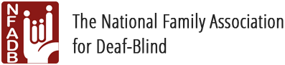
A nonprofit organization empowering families to advocate for individuals who are deaf-blind. Connects families through Facebook, webinars (in English and Spanish), a toll-free number, and a semiannual online course on the role of interveners in educational settings.

CHARGE Syndrome Foundation (www.chargesyndrome.org)
A nonprofit organization that works to improve the lives of people with CHARGE syndrome through outreach, education, and research. Supports families via a director of outreach, webinars, a provider database, extensive online resources, and an international conference every two years.

Usher Syndrome Coalition (www.usher-syndrome.org)
An advocacy and support organization where you can connect with other families, find information on the latest research and legislation, read blog posts, sign up for the newsletter, and join advocacy efforts.

FamilyConnect (www.familyconnect.org) 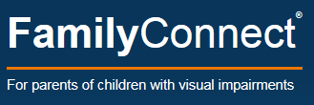
A site from the American Foundation for the Blind for parents of children with visual impairments.

Center for Parent Information and Resources (www.parentcenterhub.org) 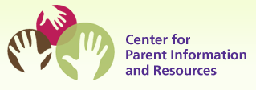
Every state has at least one federally funded parent center, which provides parents of children with disabilities information about local educational services and their child’s rights under IDEA. Visit this site to find your local parent center and browse general resources about special education.

