WHO IS THE DEAF-BLIND SPECIALIST?

The Deaf-Blind specialists with Project Reach have training specific to the needs of children with combined vision–hearing loss. They provide technical assistance to families and service providers who have children ages birth – 22 to help them understand how to work and interact with a child who has a combined vision and hearing loss. The type and intensity of technical assistance will vary based on team needs.

WHAT IS THE ROLE OF THE DEAF-BLIND SPECIALIST IN EARLY INTERVENTION?

Project Reach provides coaching and technical assistance to the child’s family and service providers based on an agreed-upon technical assistance plan. This technical assistance provides support in a number of ways which may include visits to the home or center, emails, phone calls, and dissemination of information. Project Reach does not provide direct services in the Illinois early intervention system. Project Reach provides support to adults as they work on outcomes in the child’s IFSP.

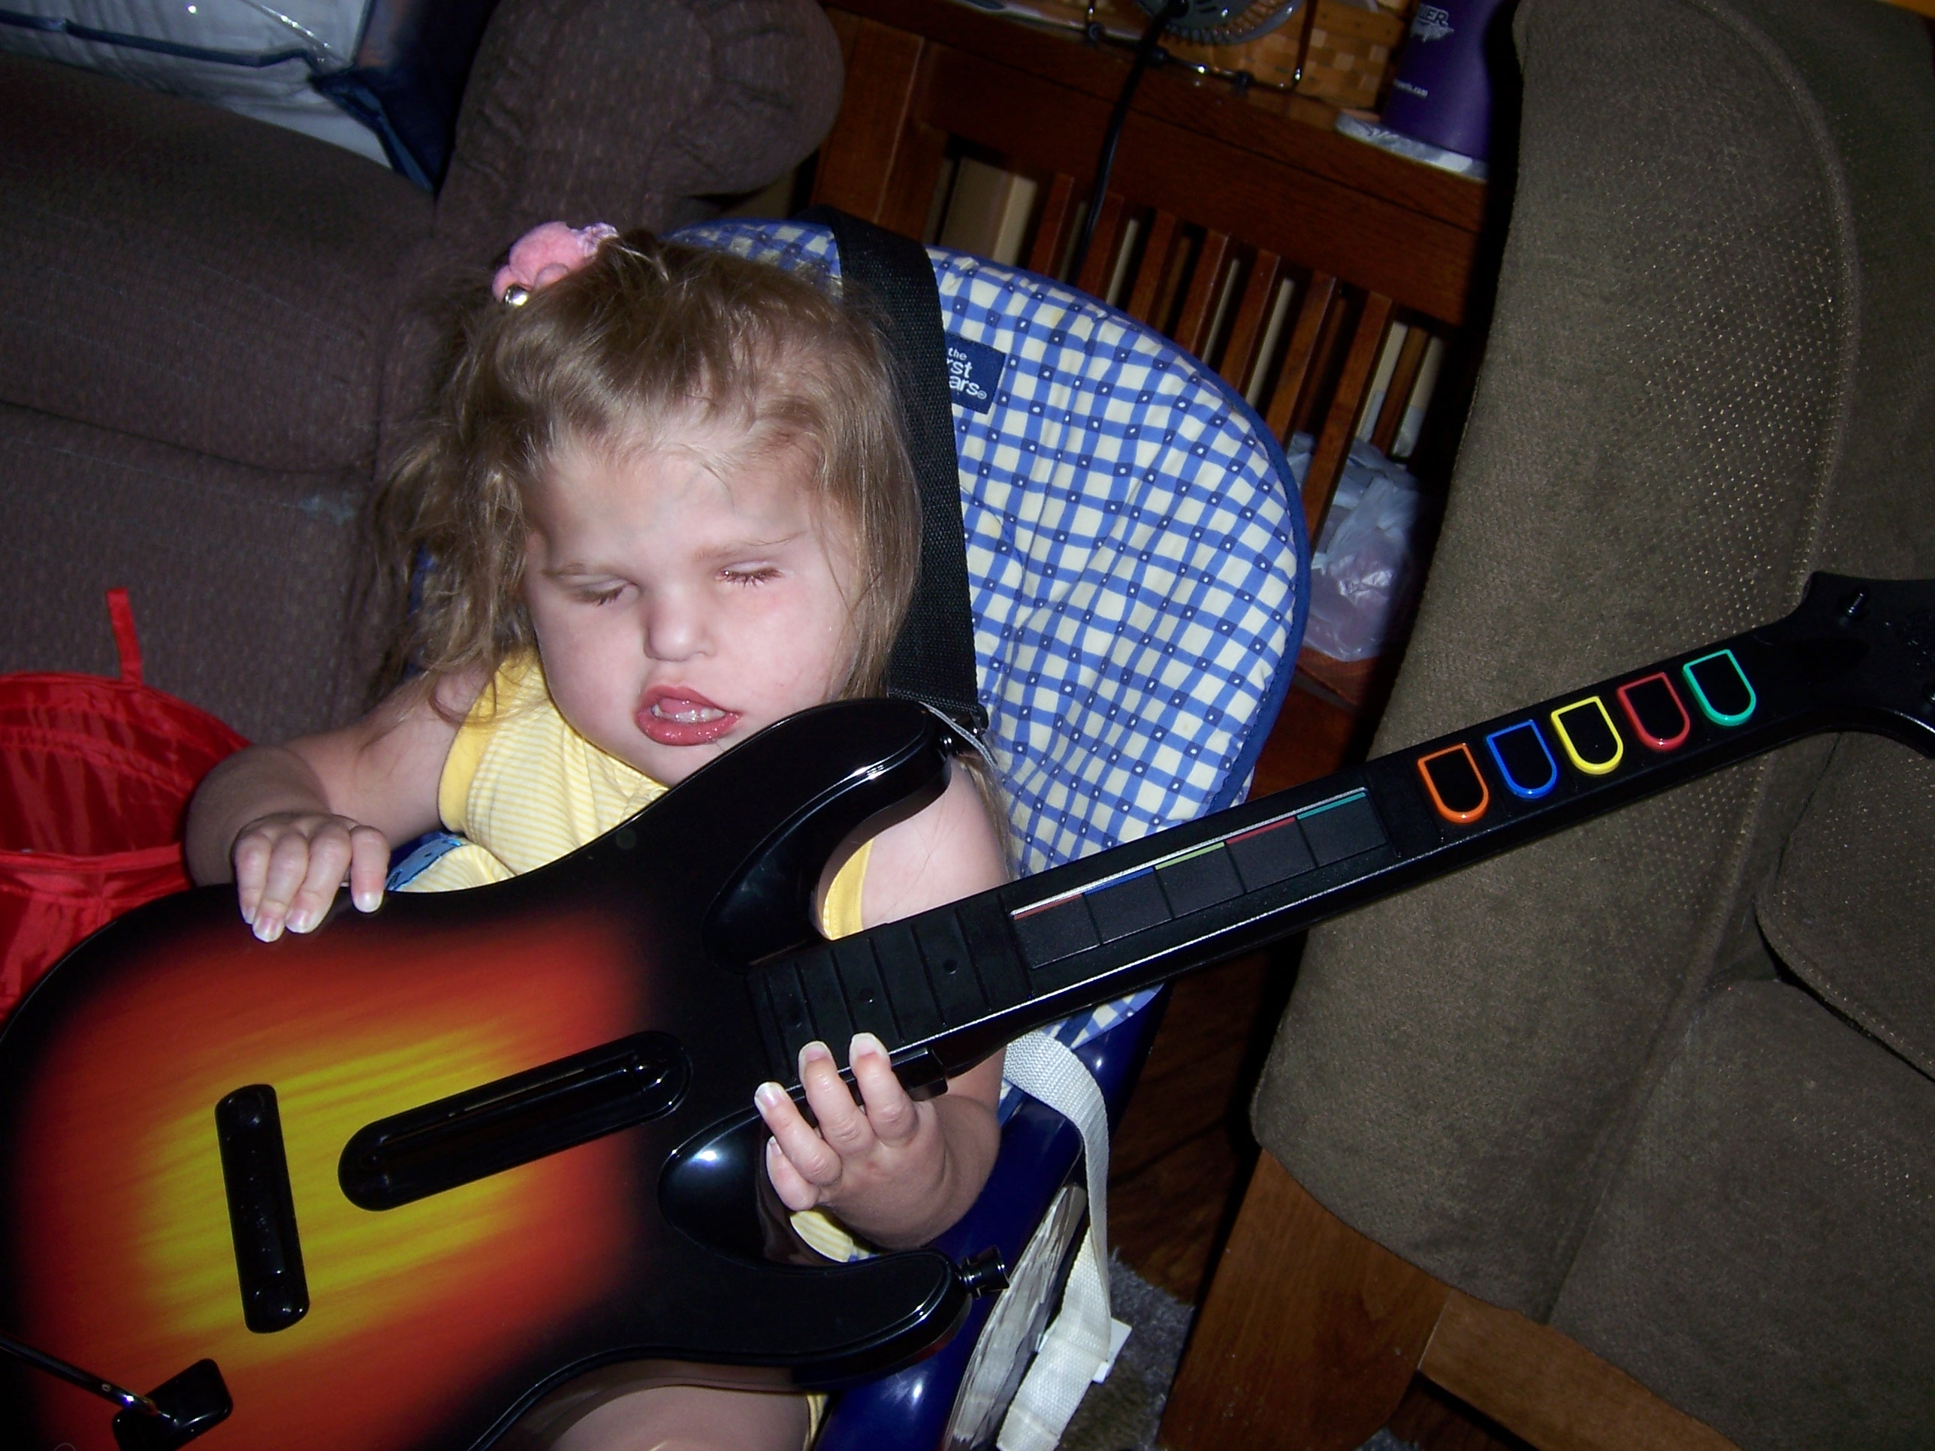

IF A CHILD ALREADY HAS A DTV AND DTH, WHY DOES THE CHILD NEED A DEAF-BLIND SPECIALIST?

Having a combined vision-hearing loss can impact a child in ways different than a child who has only a vision or a hearing loss. It is not unusual for the DTV to ask for suggestions on how to help the child explore when they would usually rely on the child’s hearing as one of the primary senses when the vision is impaired. In the same way, a DTH might ask how to promote communication with a child whose vision makes it hard for him/her to see sign language or the lips of someone who is speaking to him/her. Technical assistance can be adjusted to meet a variety of the adult learning needs.

WHO IS CONSIDERED DEAF-BLIND?

Children with deaf- blindness are children who have both auditory and visual impairments, the combination of which causes such severe communication and other developmental and educational problems that such children cannot be accommodated in the early intervention programs solely for children who are hearing impaired or visually impaired.

To be eligible for deaf-blind services, a child must have:
- a visual impairment and an auditory impairment, or
- a condition in which there is a progressive loss of hearing and vision.

- A visual impairment is defined to mean one or more of the following:

- corrected visual acuity poorer than 20/70 in better eye;
- restricted visual field of 20° or less in the better eye;
- cortical vision impairment; and
- does not appear to respond to visual stimulation, which adversely affects educational performance as determined by the multidisciplinary conference.

- An auditory impairment is defined to mean one or more of
- a sensorineural or ongoing
chronic conductive hearing loss in the better ear with
aided sensitivity of 26 dB HL or poorer;
- functional auditory behavior that is significantly discrepant from the child’s present cognitive and/or developmental levels, which adversely affects educational performance as determined by the IFSP Team.

Any child age birth-2 suspected of being deaf-blind is eligible for services as eligibility is being formally established.

HOW IS A REFERRAL MADE?
Referral for service requests to the project are made by calling or writing to
Michelle Clyne, Project Coordinator at:

Project Reach

Philip J. Rock Center & School
818 DuPage Blvd., Glen Ellyn, Illinois 60137
(630)790-2474 / (800)771-1158 (TTY)
(630)790-4893 (Fax)
Email: PRC@philiprockcenter.org
Website: http://philiprockcenter.org

PRC is located on the Northeast corner of Roosevelt Road (Route 38) and Route 53 in Glen Ellyn. From Roosevelt Road, turn North on Baker Hill Drive and turn left at the Philip J. Rock Center & School private drive.

The Deaf-Blind Specialists are:

- Karen Windy – Northwest/Central Illinois
(815)223-2037
email: windy61@comcast.net

- Carla Beck – Southern Illinois
(618)483-3062
email: carlabeck@frontiernet.net

- Jean Deptolla
(630)790-2474/ (630)709-1232
email: jeansnewlife@gmail.com

Family Specialists:

- Karen Olehy
(309)694-9072
email: kjo@bradley.edu

- Yolanda Lopez
773-912-6310
email: jdglopez@sbcglobal.net

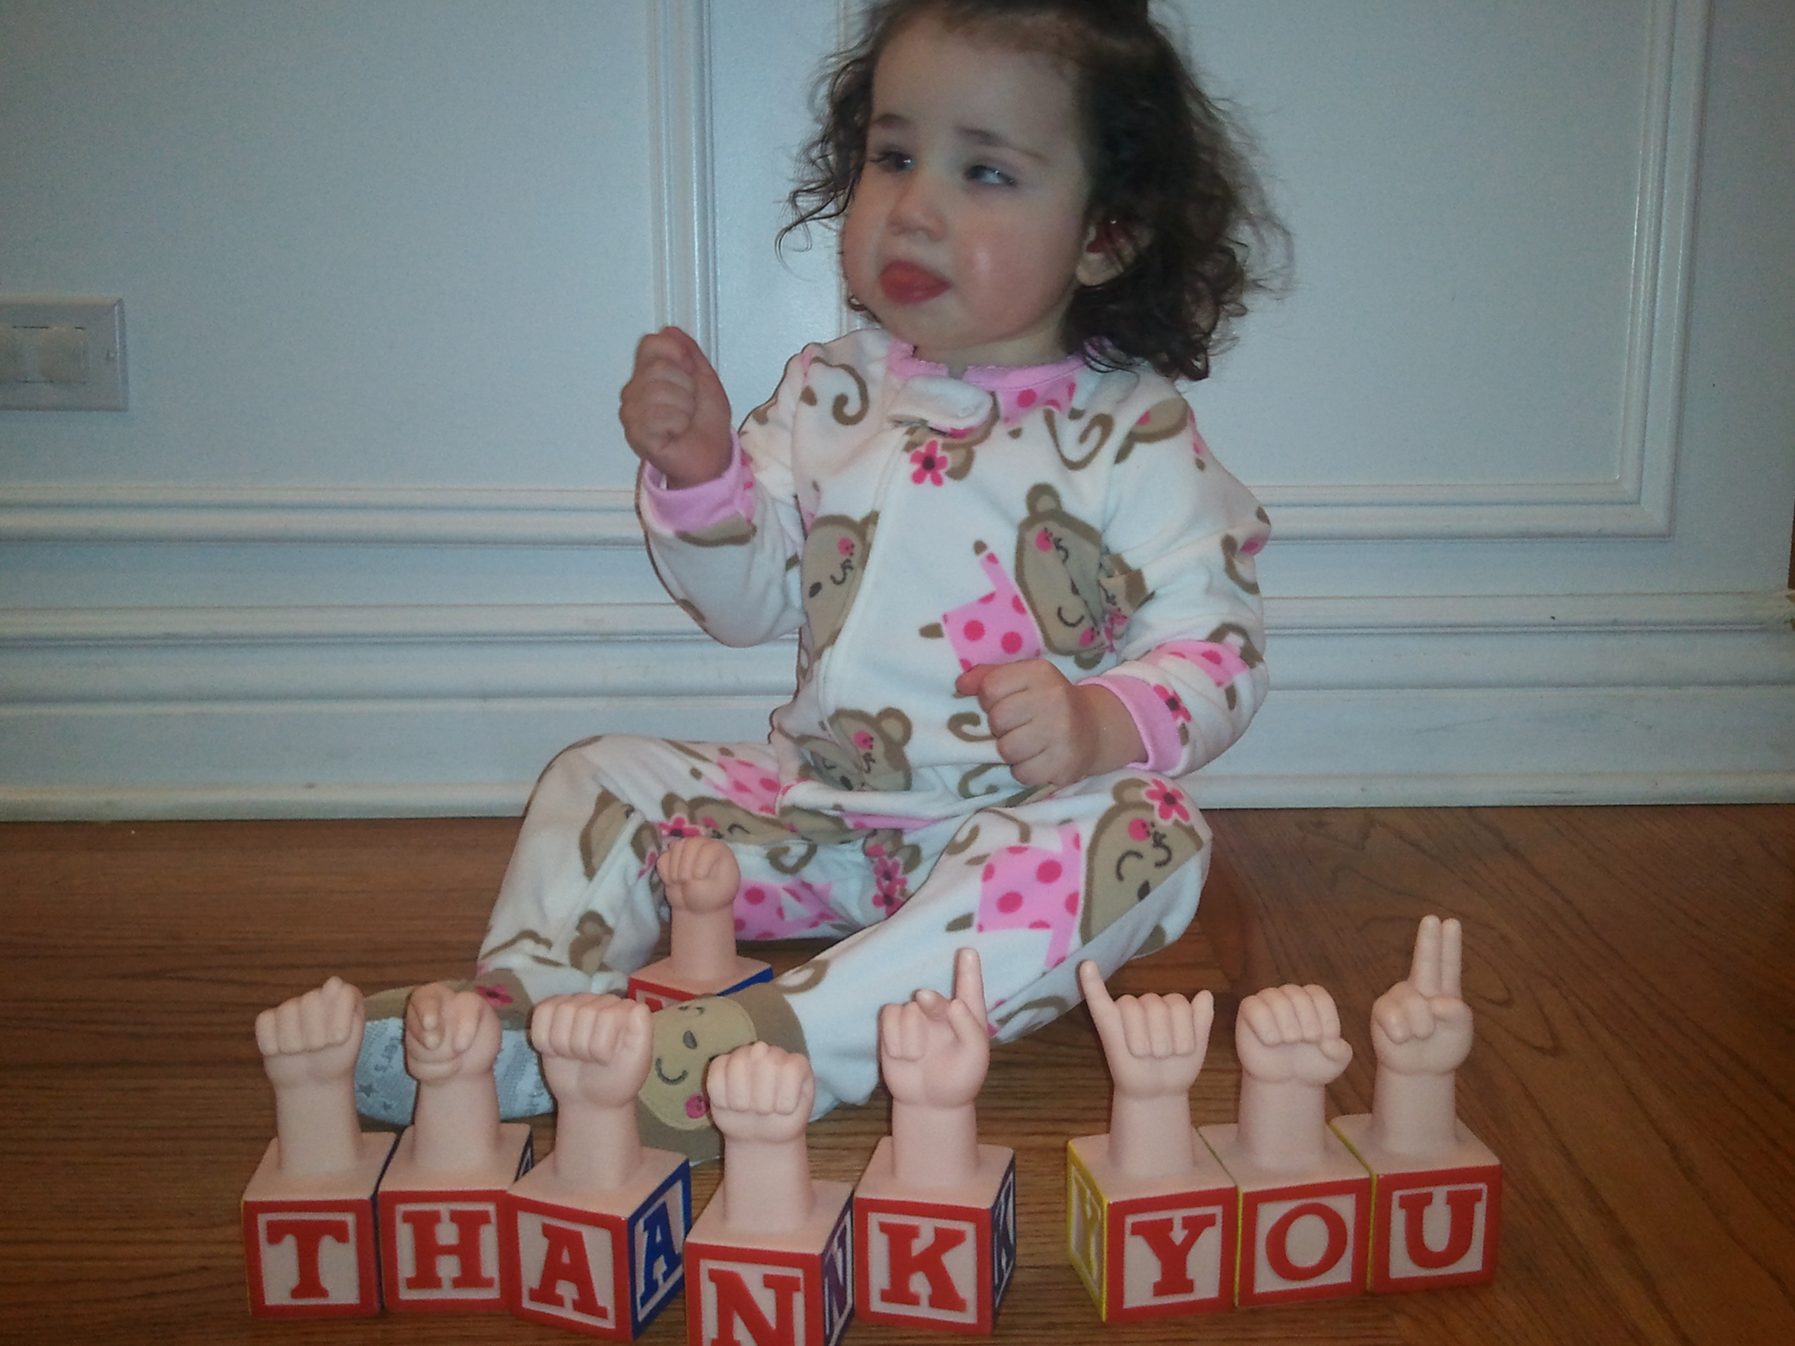

PROJECT REACH:
Illinois Deaf-Blind
Services



How We Fit In Early Intervention

818 DuPage Boulevard
Glen Ellyn, Illinois 60137

(630) 790-2474 (Voice)
(800) 771-1158 (TTY)
http://philiprockcenter.org

Todd Williams
Project Director

Michelle Clyne
Project Coordinator
Email: mclyne@philiprockcenter.org

Peggy Pausche
Executive Assistant

