Identifying Infants and Toddlers with
Combined Vision and Hearing Loss

The term deaf-blindness describes children who have both vision and hearing loss

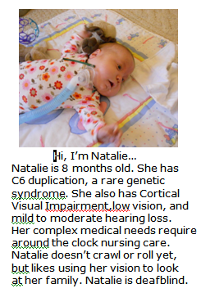
Did you know?

- Most children with deaf-blindness have different amounts of usable hearing and vision

- More than 90% of children with combined vision and hearing loss have additional disabilities or health problems

- Having multiple disabilities or complex health problems often keeps combined vision and hearing loss from being recognized or addressed in very young children

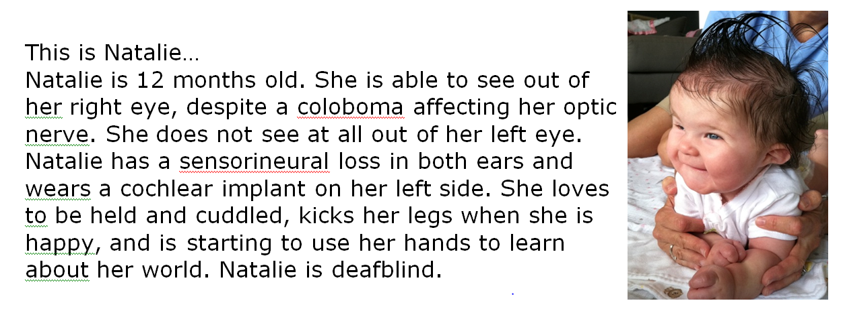

Building a Foundation for Learning

- When both vision and hearing are affected natural opportunities to learn and communicate can be severely limited

- Early intervention methods look different from those for children who have only vision or hearing loss

- Starting early helps young children learn how to use their residual vision and hearing

- State and national resources are available to support infants and toddlers with combined vision and hearing loss, their families and early intervention providers
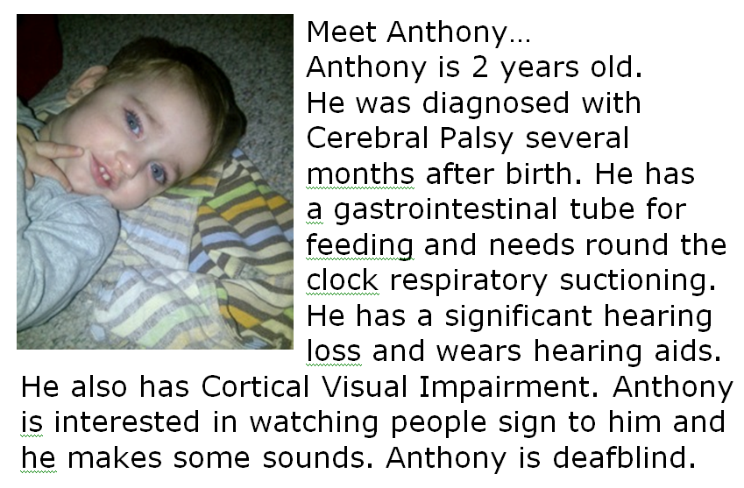

National data indicate an issue related to under identification
of infants who have both vision and hearing loss

- Approximately 9,500 children birth-21 years old are identified annually

- Over the past five years less than 1% have been infants birth to one

- This average jumps 149% to 209 children who are one year old and
increases 56% to 325 children two years of age

- The increase at three years old from Part C early intervention services to
Part B preschool services is much smaller – 20%
EHDI National Conference, April 2013

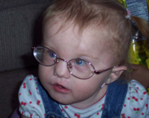

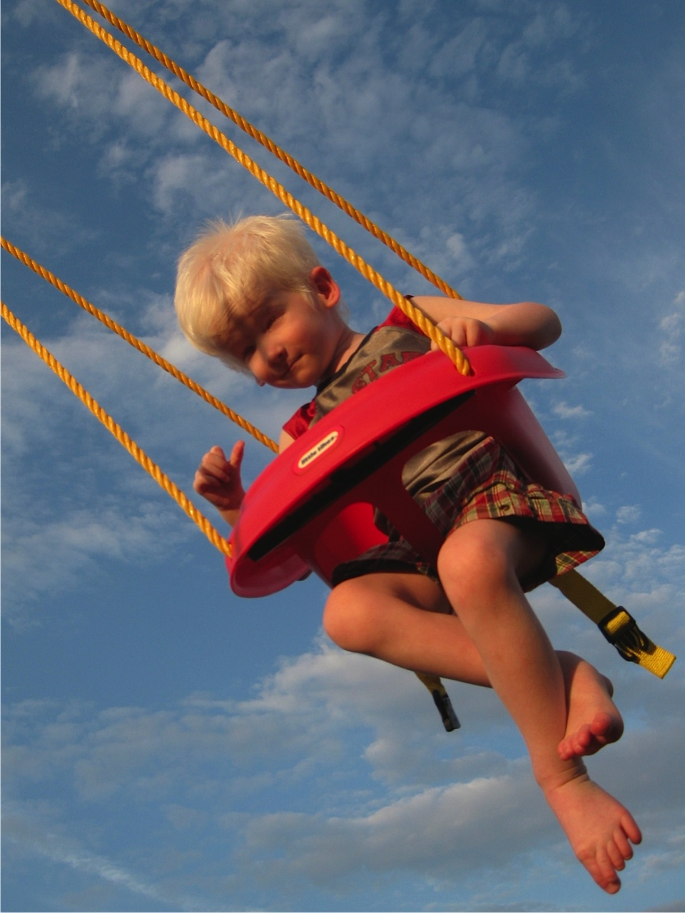
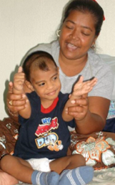

Addressing Under Identification

Part C Service Coordinators can assist in addressing the issue of under-identification.

By increasing awareness of conditions that put infants and young children at risk for combined vision and hearing loss, they can work with families to ensure appropriate referrals and evaluations.

Some Risk Factors for Combined Vision and Hearing Loss
- Maternal infection, Prenatal exposure to drugs/alcohol
- Hereditary/Genetic conditions
- Premature birth, Low birth weight / Low Apgar Scores
- Neurological injuries/Conditions
- Trauma/Injury to the eye or ear
- Multiple disabilities
- Family history of vision and hearing loss . . .

For More Information Contact

Insert DB Project information here

Thank you to Lisa Poff, IN Deaf-Blind Services Project, Shelly Voelker, FL and VI Deaf-Blind Collaborative and Emma Nelson, VT Sensory Access Project for contributing to this resource

