The Sooner the Better
INDBS Fact Sheets

Combined Vision and
Hearing Loss:
What does it mean?

The Population
In the mid to late 1960’s, more than 3,000 children were born in the United States to mothers who had Rubella (German Measles) during pregnancy. This affected both the vision and hearing of these children and they were the first large group to be identified as “deafblind.”

While Rubella is no longer a major medical prob- lem in the United States, children continue to be identified with a combined vision and
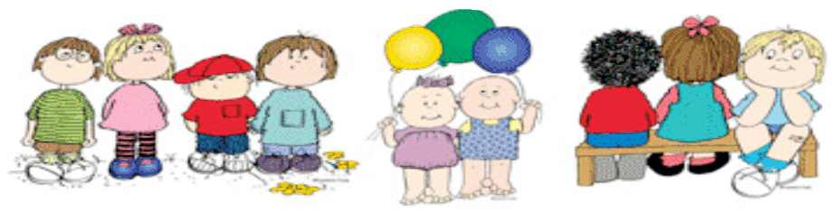hearing loss due to increased survival of premature and lo
w di
ts, p
birth weight infan as well as pre- natal, post-natal, and congenital conditions that affect vision and hearing.

Although the term deafblind implies a complete absence of hearing and sight, in reality, it refers to children with varying degrees of vision and hearing losses. The type and severity of losses differ from child to child. Even children who have the same condition causing their deafblindness will have very different amounts of usable vision and hearing and vary widely in ability. In addition, most children who are deafblind have other disabilities and many have complex health care needs. However, despite the broad
versity of the opulation, what these children have in common
is the need for specialized instruction to
meet their unique learning needs.

The Continuum of Deafblindness

The most well-known person associated with the term “deafblindness” is Helen Keller. An infection at 18 months of age left her completely deaf and totally blind. However, she really only represents a small percentage of those who are classified as deafblind – about 6%.

There are actually five categories of vision and hearing impairments. All children who are deafblind can fall anywhere along the continuum of the five categories. The categories are:

- Visually Impaired and Deaf/Hard of Hearing with Vision being the primary disability

- Visually Impaired and Deaf/Hard of Hearing with Hearing being the primary disability

- Deaf and Visually Impaired

- Blind and Deaf/Hard of Hearing

- Deaf and Blind

The Definition

Both the federal government and the state of Indiana have defined a combined vision and hearing loss using the term “deafblindness.” Both definitions are similar and include recognition of the unique nature of this population. The definitions basically state that a person is
considered to be deafblind if:

He/she has both vision and hearing impairments, the combination of which creates such severe communication and other developmental and educational problems that the student cannot be accommodated in special education programs solely for students with hearing or visual impairments. (1999 IDEA Rules and Regulations 300.7(c)(2); 2002 Indiana Administrative Code 511 IAC 7-17 through
7-31).

This definition encompasses a complete range of hearing and vision losses from mild to profound and from low vision to total blindness. In addition, often a child may have an impairment that only effects one eye or one ear or is diagnosed with
a progressive loss that currently may not be a problem.

While the meaning of the definition has remained consistent, the terminology used to describe it has changed over time, depending upon the audience. Currently, the federal government
has chosen to use the term “deafblindness” to describe combined vision and hearing losses. In the state of Indiana, dual sensory impairment is the term used in the legal definition and, fre- quently, people will refer to dual sensory losses. “Deafblind” is often very difficult for families to hear. The term “dual sensory impairment” is often misunderstood. As a result, talking about
combined vision and hearing loss allows us to be both more descriptive of the condition and more “family friendly.”

Additional Disabilities
in Children who are Deafblind

It is important to remember that over 90% of the children reported nationally as deafblind have one or more additional disabilities. The following were reported among children with one or more additional disabilities:

66% cognitive disability
57% physical disability
38% complex health care needs
9% behavior challenges
30% other

Data from Killoran, J. (2007). The national Deafblind child count: 1998–2005 in review. Monmouth, OR: NTAC.

Reported Vision and Hearing Loss in Children Identified as Deafblind

Vision Loss

17% totally blind or light perception only 24% legally blind
21% low vision
17% cortical vision impairment 21% other

Hearing Loss

39% severe to profound hearing loss 13% moderate hearing loss
14% mild hearing loss
6% central auditory processing disorder 28% other

Data from Killoran, J. (2007). The national deafblind child count: 1998–2005 in review. Monmouth, OR: NTAC.

Sometimes Children who are
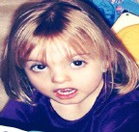Deafblind are Difficult to Spot . . .

.
It is clear that no single portrait
can be painted to represent a typical child with deafblindness. Children who are deafblind are as varied as the number reported. The photographs
and stories below illustrate this diversity. In addition, a list of some of the most common
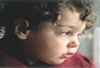causes of combined vision and hearing losses also is included.

This is Melissa . . .

Say “Hi!” to Allie . .
Allie is 3 years old. At the age of 1, tests showed that she had a moderate senso- rineural hearing loss. She also has a coloboma in each eye; however, it has not been determined how much vision
she has. In addition, Allie has blockages in her nasal pas- sages, a heart defect and has always been small for her age. She has CHARGE Syndrome. Allie is considered deafblind.

Melissa is 18 months old. She has had chronic inner ear infections and now has a severe
sensorineural hearing loss. Melissa also has cerebral palsy, seizure disorders, impaired vision due to a diseased retina, and global developmental delays. Al- though it wasn’t apparent at birth, she had Cytomegalovirus (CMV). Melissa is deafblind.

Common Causes of Deafblindness:

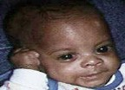CHARGE Syndrome Cornelia de Lange Syndrome Cri du chat Syndrome
Down Syndrome Hurler Syndrome Klippel-Feil Sequence
Leber Congenital Amaurosis Trisomy 13
Trisomy 18 Usher Syndrome
Congenital Rubella Congenital Toxoplasmosis Cytomegalovirus (CMV) Fetal Alcohol Syndrome Hydrocephaly Microcephaly
Asphyxia Encephalitis Infections Meningitis
Severe Head Injury Stroke
Prematurity (e.g., Low Birth Weight, Retinopathy of Prematurity)

Meet Josh . . .

Josh was born at 23 weeks and weighed 1 lb., 4 oz. He has a profound hearing loss. Josh has no vision in his left eye due to a detached retina; however, he seems to have some usable vision in his right eye. Now, at a year old, he doesn’t crawl, but scoots on his back. Josh also is deafblind.

TA, Training, & Support

Families and educators of infants, toddlers and children who are deafblind need to have access to training and support. Each state has a federally funded technical assistance project specifically designed to improve educational services, provide opportunities for training, and to help support families of children who are deafblind. For more information or to request services in Indiana contact:

Indiana Deafblind Services Project Blumberg Center, COE/University Hall 401 N. 7th St, Room 009W
Terre Haute, IN 47809
1-800-622-3035

www.indstate.edu/blumberg/db/deafblind.htm

Karen Goehl, Project Director Karen.Goehl@indstate.edu Lisa Poff, Program Coordinator Lisa.Poff@indstate.edu

This publication was prepared using various resources by Lisa Poff with the Indiana Deafblind Services Project and Barbara Purvis at the National Consortium on DeafBlindness (NCDB). However, we would specifically like to thank the National Consortium on Deafblindness, as much of the information contained in this document can be found in their Children Who Are
Deaf-Blind, Practice Perspectives - Highlighting Information on Deaf-Blindness, Number 2 (November 2007) publication. To see the entire document please go to www. nationaldb.org.

Key Points to Remember

- Deafblindness is varied and complex.

- Children with deafblindness are as diverse as the number of children reported.

- Early identification and intervention are
essential.

- Children and youth who are deafblind often have other disabilities.

- Training and support are available through federally funded technical assistance projects in each state.

Resources

Killoran, J. (2007). The national deaf-blind child count: 1998–2005 in review. Monmouth,
OR: National Technical Assistance Consortium for Children and Young Adults who are DeafBlind (NTAC), Teaching Research Institute, Western Oregon University. Available at: http://documents.nationaldb.org/products/Childcountreview0607Final.pdf

Kimberling, W. J. (2004). Genetic hearing loss
associated with eye disorders. In H. V. Toriello,
W. Reardon, & R. J. Gorlin (Eds.), Hereditary hearing loss and its syndromes (pp. 126–165). New York: Oxford University Press.

Brown, D., & Bates, E. (2005, Spring). A personal view of changes in deafblind population, philosophy, and needs. DeafBlind Perspectives, 12(3), 1–5.

For additional resources and information
about deafblindness, go to www.nationaldb.org.

The purpose of the Indiana Deafblind Services Project’s (INDBS) The Sooner the Better Fact Sheets is to increase knowledge of early intervention and early childhood education personnel, families, medical and community agency personnel about factors related to combined vision and hearing loss in young children.

