[Insert state deaf-blind project logo]

Intervener Training Pilot Project
Information for Schools and Agencies
In collaboration with state deaf-blind projects, the National Center on Deaf-Blindness (NCDB) is conducting an intervener training pilot project during the 2017-2018 school year. The project provides a wonderful opportunity for schools or agencies with a staff member who would like to receive intervener training to obtain it free of charge.
The training will include:
- An online course of study—hosted by an expert in deaf-blindness—using modules developed by the National Center on Deaf-Blindness
- Coaching and consultation from state deaf-blind project personnel
- State deaf-blind project support of the candidate as he or she develops a portfolio required for certification

Why Interveners?
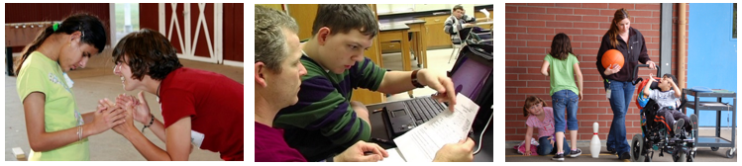
Interveners help schools meet the challenge of providing students who are deaf-blind with access to information they are unable to gather via vision and hearing. An intervener works one-on-one with a student, facilitating communication and supporting concept development.
In educational settings, interveners are typically paraeducators who have received specialized training in deaf-blindness and the process of intervention. Nationwide, there exists a great need for trained interveners.

School/Agency Requirements
Participating schools and agencies must have:
- A child with deaf-blindness for whom the intervener candidate will be providing one-to-one intervention and support during the 2017-2018 school year
- An established educational team for the child (including family members) that will support the intervener candidate as he or she participates in the training program
- Administrators who are knowledgeable about the role of an intervener and actively support the position
- A willingness to work with state deaf-blind project personnel as they provide technical assistance to the intervener candidate and possibly the team as a whole
- The ability to provide release time, a stipend, or some other type of support that will increase the likelihood that the intervener candidate will complete the training

Benefits to Schools/Agencies and Children
Benefits of this training program include:
- High-quality professional development for the intervener
- Increased knowledge and skills for the intervener regarding the use of evidence-based practices
- Interveners that meet Council for Exceptional Children competencies
- National intervener certification
- Anticipated improved student outcomes

Courses of Study: Additional Information
The training uses the Open Hands, Open Access Deaf-Blind Intervener Learning Modules, which are aligned with CEC competencies for interveners. Three different courses of study will be offered in order to meet the needs of candidates with varying levels of experience. The most appropriate course for each participant will be determined by the participant and his or her state deaf-blind project based on years of experience, prior training, and the results of a self-evaluation (provided by NCDB) that each candidate will complete.
Each participant will also take two modules that will prepare them to develop a portfolio using the National Intervener Certification E-Portfolio (NICE) system.
During the training, participants will receive:
- Feedback on all assignments
- Support and monitoring to ensure active engagement
- Opportunities for discussion with other participants via web conferencing
- Coaching and consultation from their state deaf-blind project
- Mentoring as they develop a NICE portfolio

State Deaf-Blind Project Contact Information
[Insert project contact info]

