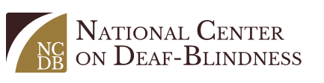
[Insert state deaf-blind project logo]

Intervener Training Pilot Project: Information for Participants
In collaboration with state deaf-blind projects, the National Center on Deaf-Blindness (NCDB) is conducting a pilot project for individuals interested in becoming certified interveners. Ideal candidates are individuals who:
- Will be providing one-to-one intervention and support to a child with deaf-blindness during the 2017-2018 school year
- Have the support of administrators and the child's educational team (including family members) to participate in the training

Why Interveners?
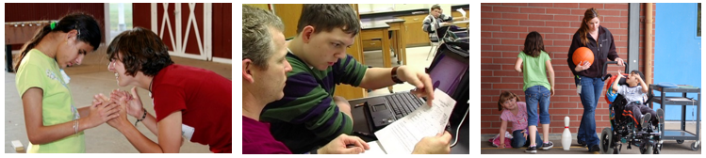
Interveners help meet the challenge of providing children who are deaf-blind with access to information they are unable to gather via vision and hearing. An intervener works one-on-one with a student, facilitating communication, social relationships, and supporting concept development.
In educational settings, interveners are typically paraeducators who have received specialized training in deaf-blindness and the process of intervention. Nationwide, there exists a great need for trained interveners.

Training Design
The training, which runs from September 2017 through June 2018, includes:
- An online course of study—hosted by an expert in deaf-blindness—using the Open Hands, Open Access (OHOA) Deaf-Blind Intervener Learning Modules
- Online meetings
- Coaching and consultation from the participant’s state deaf-blind project
- Support from the state deaf-blind project while engaging in the National Intervener Certification E-Portfolio (NICE) system and developing the portfolio required for certification
The pilot project offers three different courses of study to meet the needs of candidates with varying levels of experience. In general, participants will be divided into the following groups based on years of experience:
- Cohort 1: less than two years
- Cohort 2: more than two, but less than five years
- Cohort 3: five or more years
To determine the most appropriate cohort, however, each participant--in consultation with their state deaf-blind project--should also consider their work and volunteer experience, prior training (e.g., OHOA modules, self-study, continuing education), and the results of a self-evaluation (provided by NCDB) that each candidate will complete.

Participant Responsibilities
- Discuss your interest in participating with your state deaf-blind project
- Complete the Candidate Self-Evaluation
- Work with your state deaf-blind project to determine the cohort that best meets your needs
- Make a commitment to complete the entire course of study, including all assignments
- Attend scheduled online meetings
- Enroll in the NICE system
- Complete requirements for NICE certification

Additional Information
For more information, contact your state deaf-blind project at:

[Insert project contact information]
