Family-to-Family Communities Project (F2FC)
Connecting Families of Individuals with Deaf-Blindness via Distance Technology

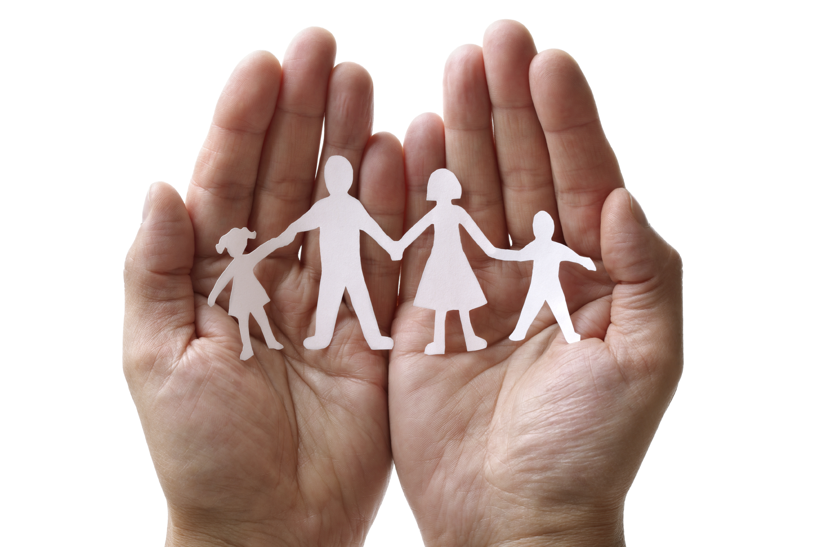
Because deaf-blindness is a rare and diverse disability, families may feel isolated or alone…like there is no one else who understands their experiences.

F2FC offers a unique way for families to connect, share information and resources, offer support to one another, and just talk to someone who “gets it.”

F2FC is open to all families, regardless of the age or diagnosis of your family member, because you share similar challenges and triumphs in the journey of supporting your family member with deaf-blindness.

Family-to-Family Communities Project Format:
- F2FC brings families together to connect, share information and resources, and offer support to one another in the journey of supporting their family member with deaf-blindness.
- Each F2FC is comprised of 8-10 families with shared commonalities and is guided by Facilitators who have participated in leadership training.
- F2FC groups meet once per month for 90 minutes, via phone and/or video conference (group preference).
- Topics are chosen by the group and include a combination of structured conversation and open sharing.
- F2FC members are encouraged to connect with each other via phone, email, or social media.
- These are not drop-in calls; your regular participation is vital to the group.
One F2FC Participant shared,
“this group gave me a vehicle for connecting with other people who have a similar experience.
It helped me feel like I wasn't alone in my journey and gave me hope for the future.”

Family-to-Family Communities Project 2018-2019 Timeline:
- Participant registration is open during June and July 2018.
- During August 2018, F2FC Facilitators will contact group members with specific call information.
- F2FC conference calls will begin in September 2018 and continue through May 2019.
- Participants will be asked to complete online surveys and participate in focus groups to share feedback.

Are you interested in joining a F2FC Community???
Registration will be open during June-July 2018
https://gsap.wufoo.com/forms/f2fc-registration-20182019/

Contact Carol Darrah, F2FC Coordinator, cdarrah@uga.edu or (706) 542-2433,
or your state deaf-blind project for more information about F2FC.

